

NOVAC TECHNOLOGY SOLUTIONS

User Manual

Document Version No.: 1.00

Revision History
Version No | Reason For Changes | Author | Approver
0.01 | Draft | Ravi Raj
1.00 | Reviewed & Approved the User Manual | Ravi Raj | NIJANTHAN PL

Table of Contents
1. Introduction 4
2. Statistics of OutwardFacultative Report 4

Introduction

The document is prepared to understand the reports generated in ZIVA application for All products. This document is being prepared in reference to:
  - Guidelines, circulars, instructions and directions released from time to time by Philippines Insurance council.

Statistics of Outward Facultative Report

System should have the provision to generate the Statistics of Outward Facultative Report based on the input parameters. This report should generate the both business type of “Outward Facultative” & “Outward Facultative Foreign”. System should generate the report in “.xls” format and this report should map under the RI report menu.

Path: Report -> Mis Report
Screen Code: 158

- Select the Mis Report from the main menu
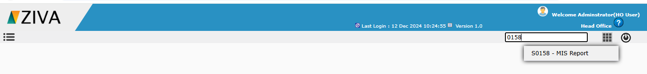

- Click on Mis report

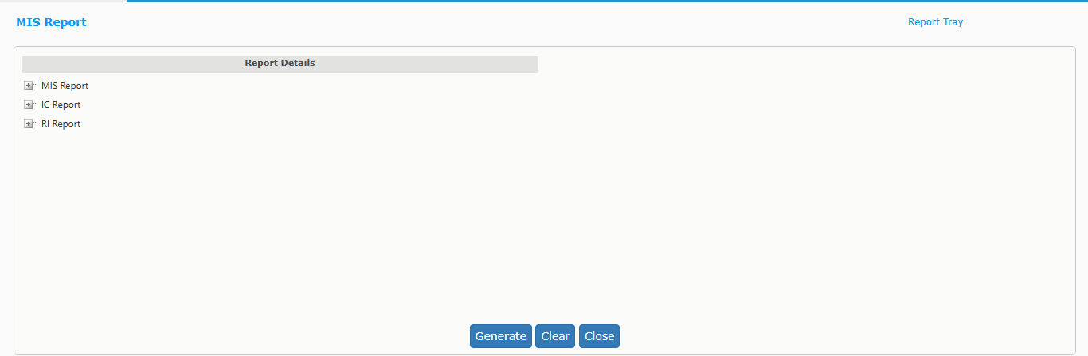

- Click on RI Report and then click on Statistics of Outward Facultative Report.

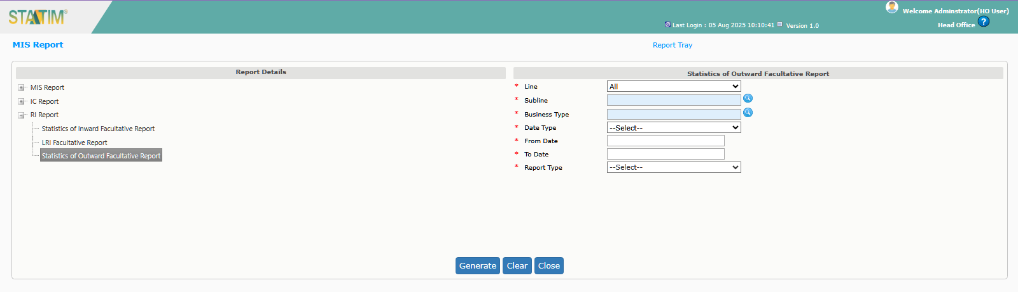

- Enter all the mandatory details and click on generate button. System will display an alert message as “Report is being generated. You may now close this window. Go through Reports Tray to view the Report”

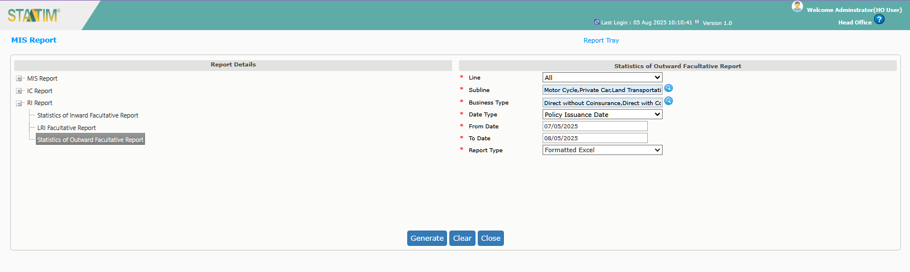

- User can download the report from the report tray.

